# **CS 1101-01: Programming Assignment Unit 6**

Godknows Egi

Bachelor of Science in Computer Science, Uopeople

CS 1101-01 - AY2024-T3: List

Bianca Gilyot

February 13th , 2024

**Question 1**

Consider that you are working as Data Analyst in an organization. The HR department needs you to carry out following operation on existing list of 10 employees name (you can assume 10 names in a list here).

* Split the list into two sub-list namely subList1 and subList2, each containing 5 names.
* A new employee (assume the name “Kriti Brown”) joins, and you must add that name in subList2.
* Remove the second employee's name from subList1.
* Merge both the lists.
* Assume there is another list salaryList that stores salary of these employees. Give a rise of 4% to every employee and update the salaryList.
* Sort the SalaryList and show top 3 salaries.

Write the Python code and output for the same.

**Question 2**

Design a program such that it converts a sentence into wordlist. Reverse the wordlist then. Write the code and output for the same.

**Answer to question 1**

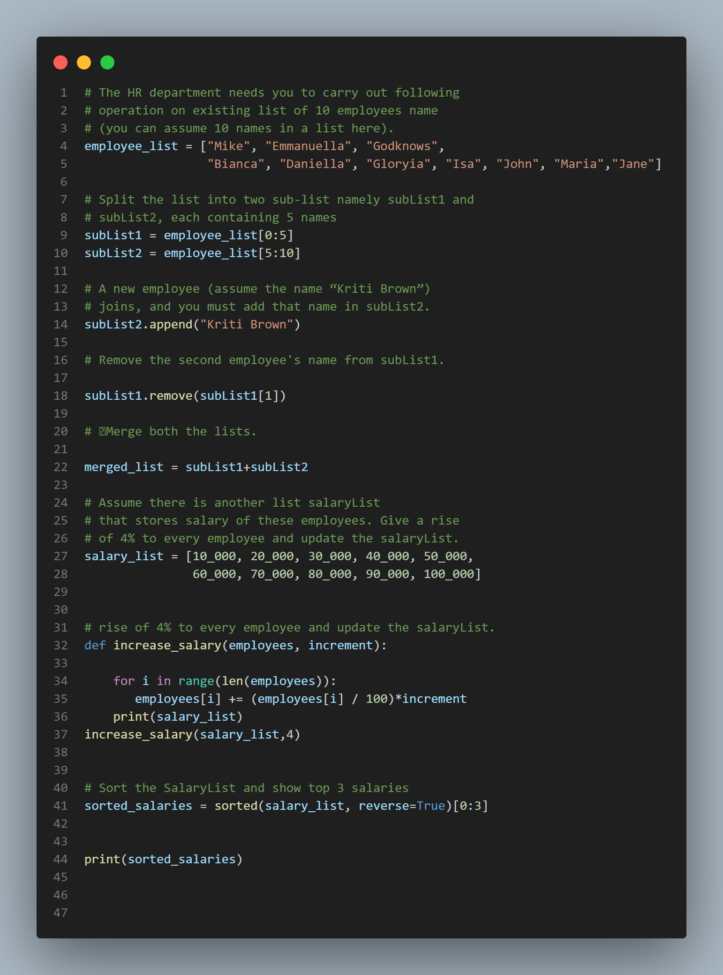

**Fig 1 *(code function)***

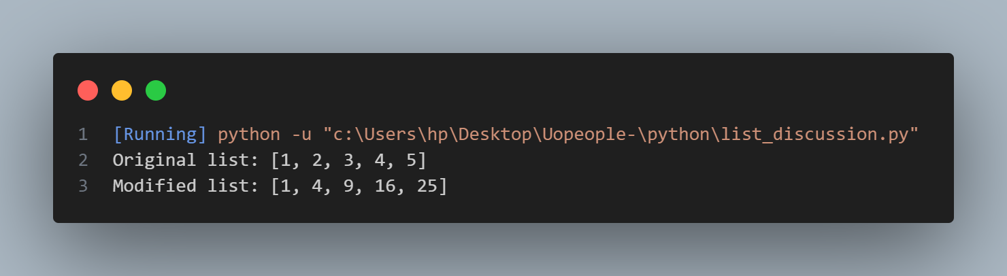

**Fig 1 Code output**

1. Firstly I declared my list of 10 employees which are as follows:
2. Secondly I split them into 2 different sublist as requested from the instructions
3. I added a new employee to list 2
4. Removed the second employee in sub list 1
5. I merged both list
6. Created a salary object for each employee
7. Created a function that will increase each employees salary by 4%]
8. Sorted the top 3 salaries in descending orders

**Answer to question 1**

Here's a Python program that takes a sentence as input, converts it into a list of words, reverses the order of the words in the list, and then prints the reversed word list:

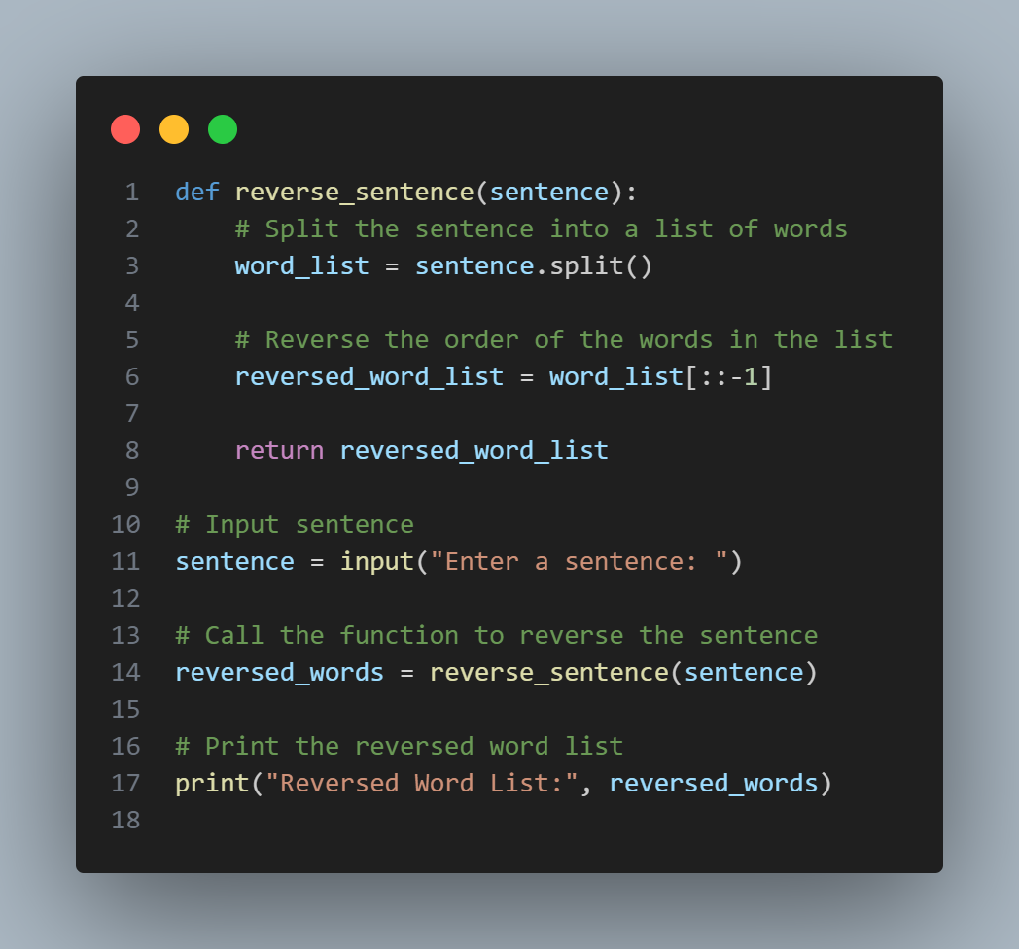

**Fig 2 *(code function to convert sentence to a list of words)***

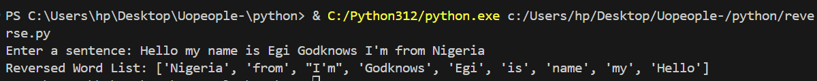

**Fig 2 Output**

1. I defined a function called **reverse_sentence** that takes one parameter sentence. This function is responsible for converting the sentence into a list of words and then reversing the order of the words.
2. Inside the function, we use the **split()** method on the sentence string to split it into a list of words. By default, **split()** splits the string on whitespace as stated on Downey, 2015, *List (chapter 10.10) page 95*, so each word in the sentence becomes an element in the resulting list **(word_list)**.
3. I used Python's list slicing with a step of -1 ([::-1]) to reverse the order of elements in the **word_list**. This creates a new list called **reversed_word_list** containing the words in reverse order and return the **reversed_word_list** from the function
4. Outside the function, i prompt the user to input a sentence using the input() function. Then I store the input sentence in the variable called **sentence**.
5. I call the **reverse_sentence** function with the **sentence** variable as an argument. This invokes the function and passes the input sentence to it.
6. The function returns the reversed word list, which i stored in the variable **reversed_words**. then I print this reversed word list to the console using print().

**References**

Downey, A. (2015,). Think Python: How to think like a computer scientist ,*Chapter 10.10,-Lists (pp 95)*

<https://greenteapress.com/thinkpython2/thinkpython2.pdf>